**BPMN Modelling**

Business Process Modelling Notation (BPMN) is a flow chart method that models the steps of a planned business process from end to end. A key to Business Process Management, it visually depicts a detailed sequence of business activities and information flows needed to complete a process. Its purpose is to model ways to improve efficiency, account for new circumstances or gain competitive advantage. The method has been undergoing a standardization push in the past few years and is now often called by a slightly different name: Business Process Model and Notation, still using the BPMN acronym. It differs from Unified Modelling Language (UML) used in software design. This chapter we will briefly explain on how each Pool or Level works on or Business Process Modelling notation Diagram.

**Register**

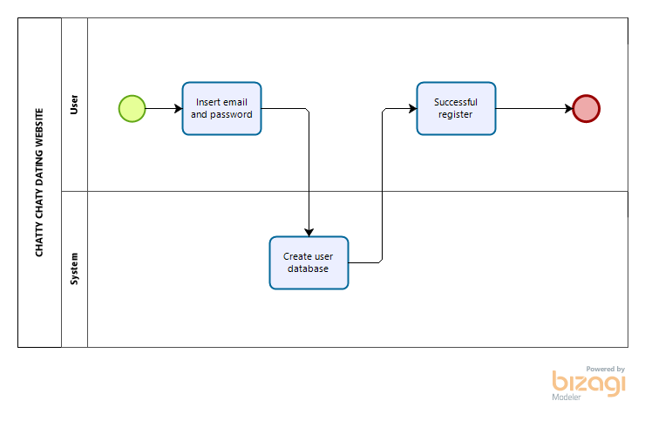

The first lane is User. This section are used by the user to register at CHATTY CHATTY dating website and user need to register their account on our website. User need to enter their email and password. For the second lane, user account will be create in our website database. After succeed, user will get successful register notification.

**Login**

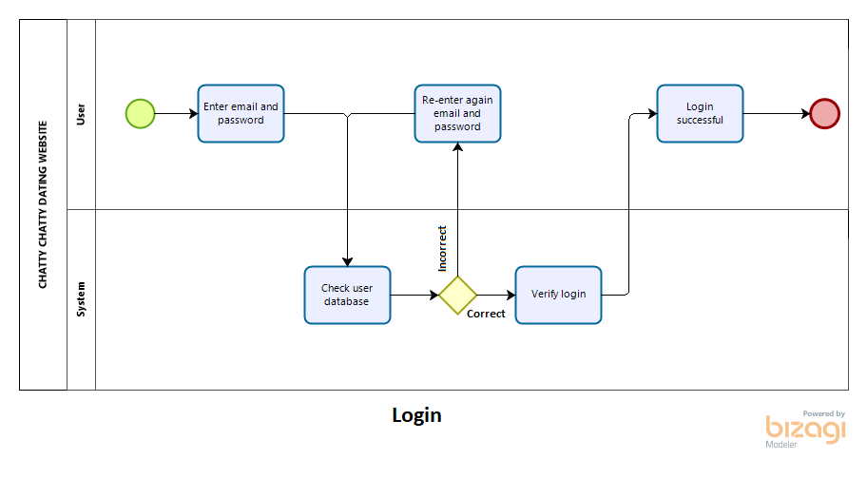

The first lane is User. This section are used by the user to login at CHATTY CHATTY dating website and users need to login their account on our website. User need to enter their email and password. For the second lane, user account will be check in our website database. If user put wrong email or password, user need to re-enter again email and password. After check, system will verify login. After succeed, user will get login successful notification and login in our website.

**Search**

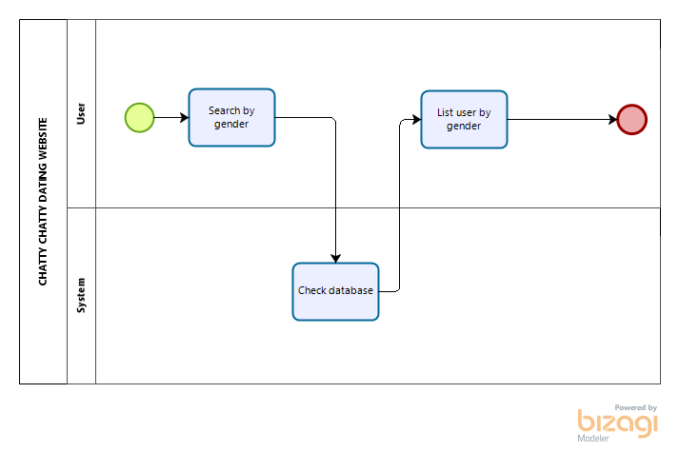

The first lane is User. This section are used by the user to search at CHATTY CHATTY dating website and users can search for other user account on our website. User need to search by gender. For the second lane, system will be check user search in our website database. After succeed, user will get list user by gender.

**Chatting**

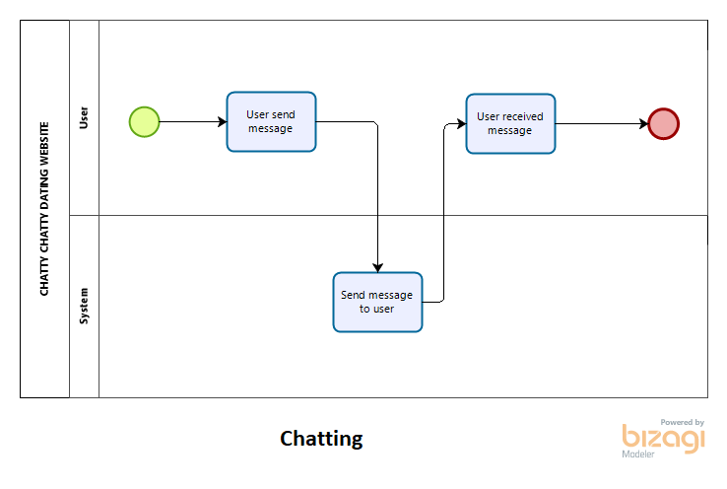

The first lane is User. This section are used by the user to chat at CHATTY CHATTY dating website and users can chat with other user account on our website. User will get limited chat and user can send message to other user. For the second lane, system will send message to other user in our website database. After succeed, user will received message.

**VIP user**

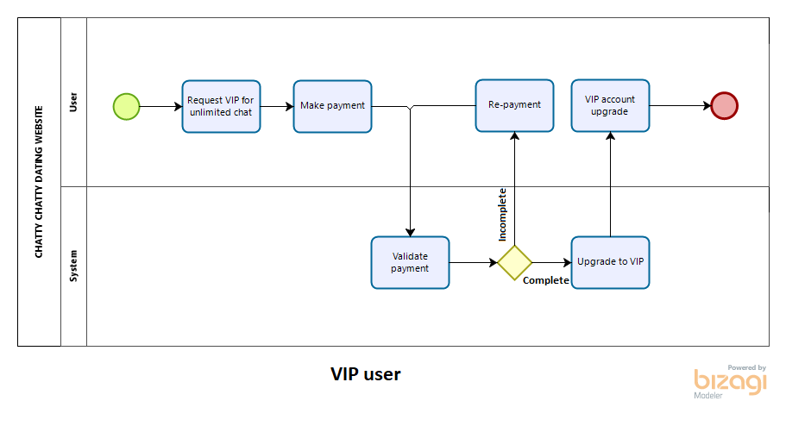

The first lane is User. This section are used by the user to upgrade VIP at CHATTY CHATTY dating website and users can request VIP on our website. User reach limited chat and user can request VIP. After that, user need to make payment on our website. For the second lane, system will validate payment by user. If payment not complete, user need to remake payment again. System will upgrade user to VIP. After succeed, user will get VIP notification.